Output:

All 5 operations in switch case are performed and verified with the correctness in output

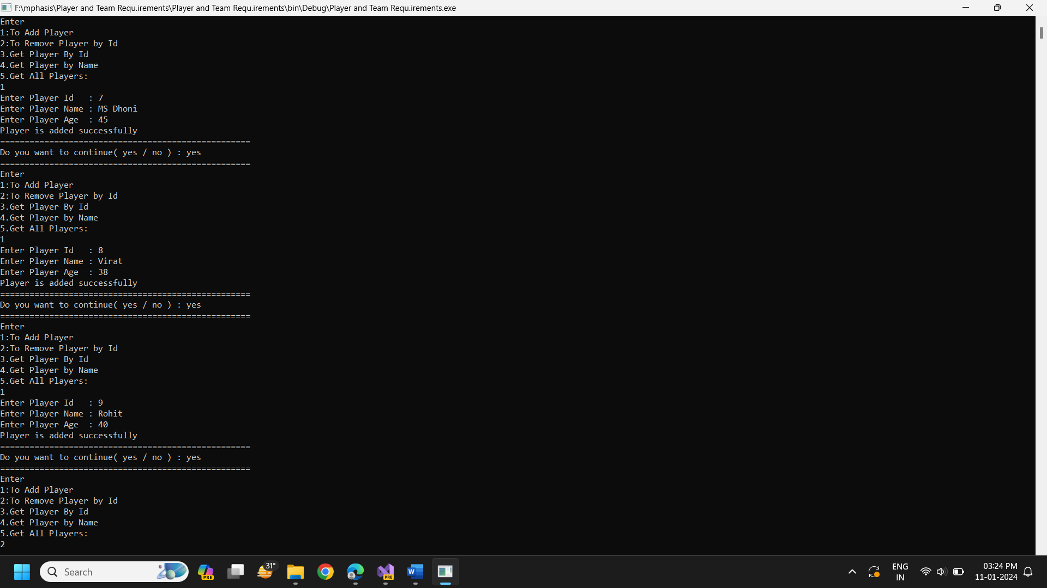

1. Added 3 players to team

-MS Dhoni

-Virat

-Rohit

2.Removed one player

-Virat

3.Get Detail of Player with ID:9

- 9 Rohit 40

4. Get Detail of Player with Name: Ms Dhoni

- 7 MS Dhoni

5. Get All Players

- MS Dhoni 45

- Rohit 40

